Name: Sanika Botre PRN: 25070122063
Batch: 2025-29 Branch: CSE A-2
Subject: Programming with Java

ASSIGNMENT No: 2

TITLE : Develop a Java application demonstrating the use of default, parameterized, and copy constructors for object initialization and data management.

Problem Statement: Develop a Java application demonstrating the use of default, parameterized, and copy constructors for object initialization and data management.

Learning Objectives: To understand and implement default, parameterized, and copy constructors for object initialization.

Theory:

Constructors are special member functions that are automatically invoked when an object is created. Java supports default constructors provided by the compiler, parameterized constructors for initializing objects with user-defined values, and copy constructors (implemented manually) for creating duplicate objects. Constructors improve code readability and simplify object initialization while supporting object-oriented programming principles.

Exercise:

1. Create a Student class using default and parameterized constructors to initialize student name and roll number.

Code:-

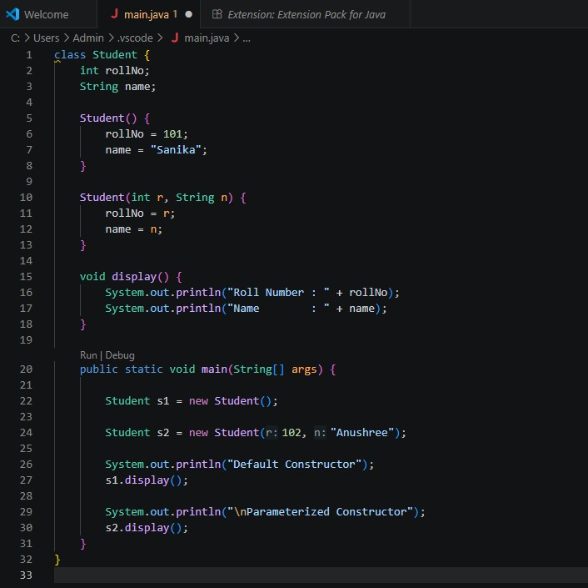

Output:-

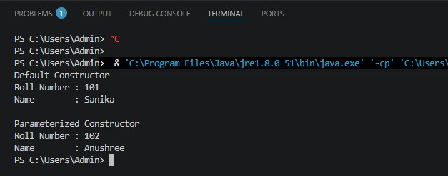

2. Develop a Mobile Phone Inventory System using different constructors to initialize mobile details and create duplicate object records.

Code:-

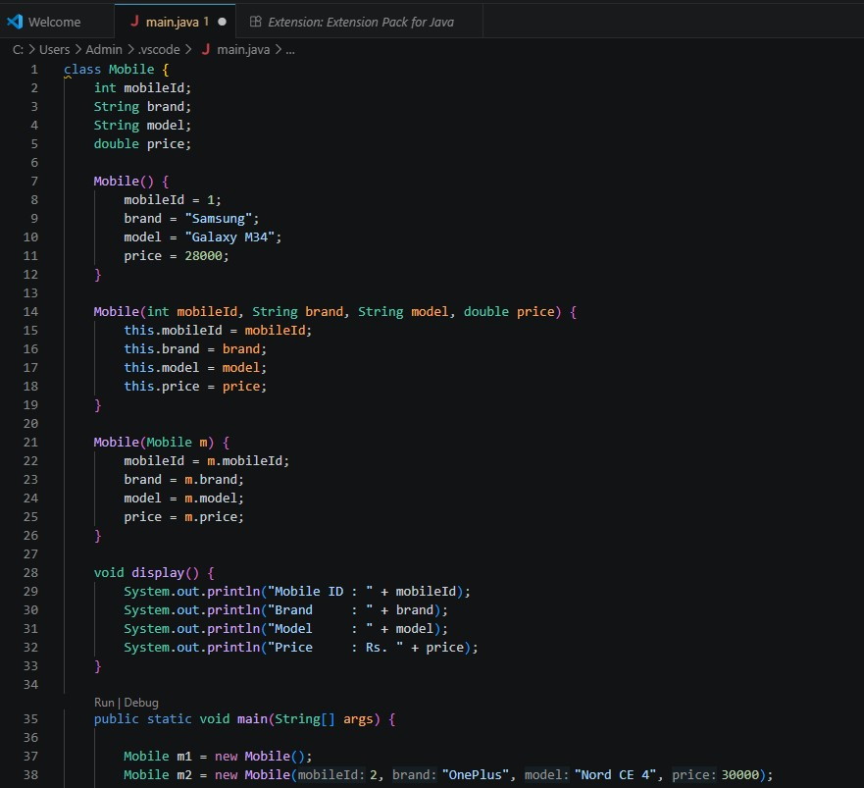
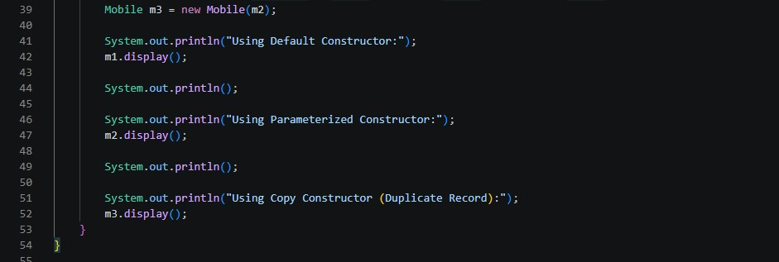

Output:-

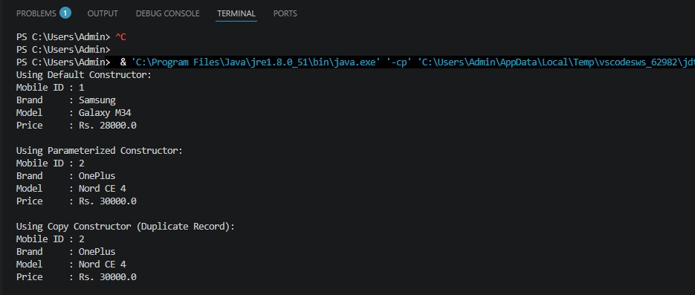

Conclusion:

The program successfully demonstrated the use of default, parameterized, and copy constructors in Java. The default constructor initialized objects with predefined values, the parameterized constructor initialized objects using user-defined values, and the copy constructor created a duplicate object by copying an existing object's data. This assignment helped in understanding object initialization, constructor overloading, and data management using constructors in Java.

